Dear Board of Executives,

On behalf of Group AA-3, we are pleased to demonstrate our project: *Design of a New, 50 Metric Ton Per Day, Modular Distributed Ammonia Synthesis System*. We developed a 50 metric ton per day modular anhydrous ammonia synthesis process to meet the high demand of agricultural ammonia fertilizer in the Midwest region and establish an alternate supply chain to the customers in this region. By utilizing environmentally friendly processes, renewable energy, and technology to scale-down the process, we were able to design a process atypical from an emission-intensive ammonia synthesis process. This design is a recommendation to the request by the engineering department seeking potential alternatives to the current ammonia production supply chain. While the economic feasibility of our design is not apparent and the process currently has negative profit margins, we believe that this design can help in the future developments of small-scale modular ammonia synthesis strategies.

Yours Sincerely,

Group AA-3

Tora Gao, Zheng Shi, Leon Zhang

Design of a Small-Scale Modular Anhydrous Ammonia Synthesis Process

Tora Gao, Zheng Shi, Leon Zhang

ChemE 486

May 29th, 2020

## Abstract

Due to the high shipping costs associated with ammonia transportation and the large demands of ammonia as a fertilizer in the Midwest region, we designed a modular ammonia synthesis process with a production capability of 50 metric tons per day (mtpd). This small-scale modular process will be located in geographic proximity to agricultural customers in the Midwest to meet the large ammonia fertilizer demands and provide an alternate supply chain to these customers. Our proposed process can be broken down into three parts: the upstream nitrogen production process, the upstream hydrogen production process, and the downstream ammonia synthesis loop. In the upstream processes, nitrogen gas is generated through pressure swing absorption (PSA) and hydrogen gas is generated through alkaline electrolysis. The two components are essential raw materials for producing ammonia. The downstream process is an absorbent enhanced ammonia synthesis process consists of a catalyst enhanced fix bed reactor, typical in Haber-Bosch ammonia synthesis processes, and an absorption system that recovers ammonia as opposed to a condenser and separator used in a typical Haber-Bosch process. The efficient ammonia recovery by the absorption system allows the ammonia synthesis reaction to be carried out at much lower pressures thereby reducing the size and costs associated with the process to make a small-scale process viable. Using the Aspen Plus v8.6 simulator, we designed our process and evaluated various factors associated with it.

Our final design utilized six ammonia synthesis modules run in parallel to meet the 50 mtpd production goal. By using the modular design strategy and incorporating process intensification strategies such as reactive-absorption, we were able to successfully to scale-down the Haber-Bosch process to the desired production goal. The absorption feature of our process enabled us to successfully reduce the operating pressure and equipment size/costs while the use of electrolysis for hydrogen production significantly reduced the carbon emission of our process. The utilization of cheap renewable electricity from wind energy in the Midwest region helped to decrease utility costs associated with energy-intensive processes such as electrolysis. However, our process is currently not economically viable and will not make any profit within its project lifetime of 20 years.

We recommend increasing the individual modular sizes and increase the production rate of each module. By doing so, we can further mitigate the effects of loss of economy of scale and increase our profit margins with increased production capabilities. The overall process will still be at a small-scale but because of the large demand in ammonia fertilizer in the Midwest region, we believe an increased production rate is justifiable. Additionally, better power purchase agreements could be negotiated to further reduce the cost of electricity from renewable wind energy and decrease utility/operating costs. An energy storage system can be built for the electrolysis system as well where energy will be stored to create a steady supply of electricity for the process. Since the electrolysis system is currently contributing to a large fraction of the capital and operating costs, other methods to produce hydrogen can be employed that are much cheaper; although, these methods may not result in reduced carbon emissions.

## Contents

Introduction……………………………………………………………………………………….1

Process Flow Diagram and Material Balances……………………………………………………2

Process Description……………………………………………………………………………….6

Equipment List and Unit Descriptions……………………………………………………………8

Equipment Specification Sheet…………………………………………………………………..10

## Equipment Cost Summary………………………………………………………………………..15

## Fixed Capital Investment Summary……………………………………………………………...18

## Energy Balance and Utility Requirements………………………………………………………..19

## Manufacturing and Operation Costs……………………………………………………………...21

## Economic Analysis……………………………………………………………………………….23

## Safety, Health, and Environmental Considerations………………………………………………27

## Process Safety Considerations……………………………………………………………………29

## Other Important Considerations………………………………………………………………….32

## Conclusion and Recommendations………………………………………………………………35

## Acknowledgements………………………………………………………………………………36

## Bibliography……………………………………………………………………………………..37

## Appendix…………………………………………………………………………………………39

## Introduction

Ammonia accounts for 1-3% of the world’s energy consumption, 5% of natural gas consumption, and around 3% of greenhouse gas emissions. Because of the significances of these factors, a more sustainable and environmentally friendly way of manufacturing ammonia is desired. However, due to the energy-intensive nature of typical chemical processes (i.e. Haber-Bosch) used in ammonia production, these processes are typically located along the Gulf Coast in the US due to the high availability of natural gas. Moreover, the extreme operating conditions of a typical ammonia plant inevitably make it a very large plant. Additionally, most of the synthesized ammonia is used as agricultural fertilizer; therefore, it must be shipped to regions such as the Corn Belt in the Midwest region. Ammonia is a toxic gas at ambient conditions thus requiring expensive shipping and insurance costs. Therefore, designing a small-scale ammonia synthesis plant in geographic proximity to the customers in the Midwest is ideal in reducing transportation costs, providing an alternate supply chain for these customers, and meeting the large ammonia fertilizer demand in the region.

We were asked by the engineering department for such a design that would serve as an alternative supply chain to the current ammonia production process. By utilizing the Aspen Plus v8.6 simulator and vigorously investigating external literature/resources, we designed a modular ammonia synthesis plant that fitted the design criteria set forth by the engineering department. Our design consists of an upstream nitrogen production process using pressure swing adsorption (PSA), an upstream hydrogen production process using alkaline electrolysis, and a downstream reactive-absorption ammonia synthesis loop that can produce 50 metric tons per day (mtpd) of anhydrous ammonia at a purity of 99.6% by mass. Along with a full technical characterization of our proposed design, we also conducted a preliminary economic analysis and an environmental/health/safety analysis to accompany the technical design.

## Process Flow Diagram and Material Balance

## The process flow diagram (PFD) for the process we have designed and suggest is shown below in figure 1. This PFD outlines the process for a single modular unit with a capacity of around 8.9 mtpd of anhydrous ammonia at a purity of 99.6% by weight. There will be six parallel modules to meet the production goal of 50 mtpd. This manufacturing method is called parallel modular manufacturing where a unit scale for a process module is first determined and the desired production rate is achieved by running multiple modules in parallel. Rather than a typical scaling-up approach, this method utilizes a numbering-up approach.

## 

## Figure 1. Process flow diagram for a single modular unit of anhydrous ammonia production. A single module has as production capacity of 8.9 mtpd of anhydrous ammonia at 99.6 % purity by weight.

## The details of the process and streams are summarized as streamflow tables that is shown below in tables 1.1 – 1.5. Like the PFD shown above in figure 1, the values shown in the streamflow tables are for one module production unit.

## Table 1.1. Stream flow table that summarizes major stream conditions for streams 1 – 7 in a single module unit of the anhydrous ammonia production process.

|  |  |  |  |  |  |  |  |  |
| --- | --- | --- | --- | --- | --- | --- | --- | --- |
| **Stream #** | **Unit** | **1** | **2** | **3** | **4** | **5** | **6** | **7** |
| Water | Kmol/hr | 0.53 | 0.53 | 0.53 | 0.53 | 0.52 | 0.0 | 0.0 |
| Hydrogen Gas | Kmol/hr | 0.0 | 0.0 | 0.0 | 0.0 | 0.0 | 0.0 | 0.0 |
| Nitrogen Gas | Kmol/hr | 34.7 | 34.7 | 34.7 | 34.7 | 0.0 | 13.7 | 20.96 |
| Oxygen Gas | Kmol/hr | 9.45 | 9.45 | 9.45 | 9.45 | 0.0 | 0.1 | 9.37 |
| Argon | Kmol/hr | 0.33 | 0.33 | 0.33 | 0.33 | 0.0 | 0.0 | 0.33 |
| Ammonia | Kmol/hr | 0.0 | 0.0 | 0.0 | 0.0 | 0.0 | 0.0 | 0.0 |
| Total Flow | Kmol/hr | 45.0 | 45.0 | 45.0 | 45.0 | 0.52 | 13.8 | 30.66 |
| Total Flow | Kg/hr | 1297 | 1297 | 1297 | 1297 | 9.43 | 387.4 | 900.1 |
| Total Flow | L/min | 17955.0 | 17955.0 | 17955.0 | 17955.0 | 0.16 | 735.7 | 1630.4 |
| Temperature | C° | 15.0 | 332.5 | 35.0 | 35.0 | 35.0 | 35.0 | 35.0 |
| Pressure | Bar | 1.0 | 8.0 | 8.0 | 8.0 | 8.0 | 8.0 | 8.0 |
| Vapor Frac |  | 1.00 | 1.00 | 0.99 | 1.00 | 0.00 | 1.00 | 1.00 |

## Table 1.2. Stream flow table that summarizes major stream conditions for streams 8 – 14 in a single module unit of the anhydrous ammonia production process.

|  |  |  |  |  |  |  |  |  |
| --- | --- | --- | --- | --- | --- | --- | --- | --- |
| **Stream #** | **Unit** | **8** | **9** | **10** | **11** | **12** | **13** | **14** |
| Water | Kmol/hr | 39.0 | 51.6 | 51.6 | 51.6 | 10.4 | 10.4 | 0.2 |
| Hydrogen Gas | Kmol/hr | 0.0 | 0.0 | 2.5 | 2.5 | 0.0 | 0.0 | 0.0 |
| Nitrogen Gas | Kmol/hr | 0.0 | 0.0 | 0.0 | 0.0 | 0.0 | 0.0 | 0.0 |
| Oxygen Gas | Kmol/hr | 0.0 | 0.0 | 0.0 | 0.0 | 19.3 | 19.3 | 19.3 |
| Argon | Kmol/hr | 0.0 | 0.0 | 0.0 | 0.0 | 0.0 | 0.0 | 0.0 |
| Ammonia | Kmol/hr | 0.0 | 0.0 | 0.0 | 0.0 | 0.0 | 0.0 | 0.0 |
| Total Flow | Kmol/hr | 39.0 | 51.6 | 54.0 | 54.0 | 29.7 | 29.7 | 19.5 |
| Total Flow | Kg/hr | 702.6 | 929.0 | 934.2 | 934.2 | 806.2 | 806.2 | 622.4 |
| Total Flow | L/min | 11.7 | 15.5 | 1037.1 | 2140.2 | 14513.5 | 8664.0 | 1661.0 |
| Temperature | C° | 15.0 | 19.9 | 19.7 | 80.0 | 80.0 | 35.0 | 35.0 |
| Pressure | Bar | 1.0 | 3.0 | 3.0 | 3.0 | 1.0 | 1.0 | 5.0 |
| Vapor Frac |  | 0.00 | 0.00 | 0.05 | 0.08 | 1.00 | 0.68 | 1.00 |

## Table 1.3. Stream flow table that summarizes major stream conditions for streams 15 – 20 in a single module unit of the anhydrous ammonia production process.

|  |  |  |  |  |  |  |  |  |
| --- | --- | --- | --- | --- | --- | --- | --- | --- |
| **Stream #** | **Unit** | **15** | **16** | **17** | **18-1** | **18-2** | **19** | **20** |
| Water | Kmol/hr | 10.2 | 2.5 | 2.5 | 2.4 | 0.0 | 0.1 | 14.5 |
| Hydrogen Gas | Kmol/hr | 0.0 | 41.2 | 41.2 | 0.0 | 2.5 | 38.7 | 273.3 |
| Nitrogen Gas | Kmol/hr | 0.0 | 0.0 | 0.0 | 0.0 | 0.0 | 0.0 | 133.8 |
| Oxygen Gas | Kmol/hr | 0.0 | 0.0 | 0.0 | 0.0 | 0.0 | 0.0 | 19.3 |
| Argon | Kmol/hr | 0.0 | 0.0 | 0.0 | 0.0 | 0.0 | 0.0 | 0.0 |
| Ammonia | Kmol/hr | 0.0 | 0.0 | 0.0 | 0.0 | 0.0 | 0.0 | 22.3 |
| Total Flow | Kmol/hr | 10.2 | 43.7 | 43.7 | 2.4 | 2.5 | 38.8 | 463.2 |
| Total Flow | Kg/hr | 183.8 | 128.0 | 128.0 | 42.6 | 5.1 | 80.2 | 5559.2 |
| Total Flow | L/min | 3.1 | 21369.3 | 18450.4 | 0.72 | 71.0 | 1112.6 | 23482.2 |
| Temperature | C° | 35.0 | 80.0 | 35.0 | 35.0 | 35.0 | 35.0 | 119.2 |
| Pressure | Bar | 5.0 | 1.0 | 1.0 | 15.0 | 15.0 | 15.0 | 10.0 |
| Vapor Frac |  | 0.00 | 1.00 | 0.99 | 0.00 | 1.00 | 1.00 | 1.00 |

## Table 1.4. Stream flow table that summarizes major stream conditions for streams 21 – 27 in a single module unit of the anhydrous ammonia production process.

|  |  |  |  |  |  |  |  |  |
| --- | --- | --- | --- | --- | --- | --- | --- | --- |
| **Stream #** | **Unit** | **21** | **22** | **23** | **24** | **25** | **26** | **27** |
| Water | Kmol/hr | 4.1 | 4.1 | 4.1 | 4.1 | 4.1 | 0.0 | 0.0 |
| Hydrogen Gas | Kmol/hr | 306.5 | 306.5 | 306.5 | 273.3 | 273.3 | 0.0 | 0.0 |
| Nitrogen Gas | Kmol/hr | 144.9 | 144.9 | 144.9 | 133.8 | 133.8 | 0.0 | 0.0 |
| Oxygen Gas | Kmol/hr | 0.1 | 0.0 | 0.0 | 0.0 | 0.0 | 0.0 | 0.0 |
| Argon | Kmol/hr | 0.0 | 0.0 | 0.0 | 0.0 | 0.0 | 0.0 | 0.0 |
| Ammonia | Kmol/hr | 0.2 | 0.2 | 0.2 | 22.3 | 22.3 | 22.1 | 22.1 |
| Total Flow | Kmol/hr | 455.7 | 455.6 | 455.6 | 433.5 | 433.5 | 22.2 | 22.2 |
| Total Flow | Kg/hr | 4755.4 | 4752.9 | 4752.9 | 4753.1 | 4753.1 | 377.8 | 377.8 |
| Total Flow | L/min | 24875.0 | 12559.8 | 13914.9 | 13665.2 | 8968.6 | 1490.4 | 1490.4 |
| Temperature | C° | 119.2 | 317.8 | 468.2 | 403.3 | 170.0 | 400.0 | 400.0 |
| Pressure | Bar | 10.0 | 30.0 | 30.0 | 30.0 | 30.0 | 13.8 | 13.8 |
| Vapor Frac |  | 1.00 | 1.00 | 1.00 | 1.00 | 1.00 | 1.00 | 1.00 |

## Table 1.5. Stream flow table that summarizes major stream conditions for streams 28 – 34 in a single module unit of the anhydrous ammonia production process.

|  |  |  |  |  |  |  |  |  |
| --- | --- | --- | --- | --- | --- | --- | --- | --- |
| **Stream #** | **Unit** | **28** | **29** | **30** | **31** | **32** | **33** | **34** |
| Water | Kmol/hr | 0.1 | 4.0 | 4.0 | 0.0 | 0.0 | 0.0 | 0.0 |
| Hydrogen Gas | Kmol/hr | 5.5 | 267.8 | 267.8 | 0.0 | 0.0 | 0.0 | 0.0 |
| Nitrogen Gas | Kmol/hr | 2.7 | 131.1 | 131.1 | 0.0 | 0.0 | 0.0 | 0.0 |
| Oxygen Gas | Kmol/hr | 0.0 | 0.0 | 0.0 | 0.0 | 0.0 | 0.0 | 0.0 |
| Argon | Kmol/hr | 0.0 | 0.0 | 0.0 | 0.0 | 0.0 | 0.0 | 0.0 |
| Ammonia | Kmol/hr | 0.0 | 0.2 | 0.2 | 22.1 | 22.1 | 0.3 | 21.8 |
| Total Flow | Kmol/hr | 8.2 | 403.1 | 403.1 | 22.2 | 22.2 | 0.4 | 21.8 |
| Total Flow | Kg/hr | 87.5 | 4287.8 | 4287.8 | 377.8 | 377.8 | 6.1 | 371.7 |
| Total Flow | L/min | 155.0 | 7596.2 | 7596.2 | 20.8 | 20.8 | 10.4 | 10.5 |
| Temperature | C° | 170.0 | 170.0 | 130.0 | 400.0 | 32.0 | 32.0 | 32.0 |
| Pressure | Bar | 30.0 | 30.0 | 30.0 | 13.8 | 13.8 | 13.8 | 13.8 |
| Vapor Frac |  | 1.00 | 1.00 | 1.00 | 1.00 | 0.02 | 1.00 | 0.00 |

## By evaluating the mass flow rates of every stream coming into and out of the process, it can be shown that the mass balance does close for the overall process. The mass balance calculation is shown below in equations 1 – 2. The “fake separator stream” is a fake stream that only exists in our simulation to help it converge. It can be seen in the Aspen results attached in the appendix.

## Flowrate in = stream 1 + stream 8 = 518.8 kg/hr + 702.6 kg/hr ≈ 1221 kg/hr (Eq. 1)

## Flowrate out = stream 5+stream 7+stream 14+stream 28+stream 33+stream 34+fake separator stream = 3.8 kg/hr + 127.6 kg/hr + 622.4 kg/hr + 87.5 kg/hr + 6.1 kg/hr + 371.7 kg/hr + 2.5 kg/hr

## ≈ 1221 kg/hr (Eq. 2)

## Since the mass flowrate in matches that of mass flowrate out, the overall mass balance closes.

## Process Description

## Our process can be split into three distinct and key sections: the upstream pressure swing adsorption (PSA) process to produce nitrogen gas (streams 1 – 7), the upstream electrolysis process to produce hydrogen gas (streams 8 – 19), and the downstream reactive-absorption loop to synthesis anhydrous ammonia (streams 20 – 34).

## The upstream PSA process is designed to source air from the atmosphere and separate its components, using adsorption towers, to produce high-purity nitrogen gas for the downstream process. The air is first compressed and cooled through a compressor and heat exchanger to the desired operating condition of the adsorption towers. It then passes through a dust and mist filter to remove water vapor, and any dust and other potential contaminate to our process. Then, the purified air enters the adsorption tower packed with a special type of carbon molecular sieves (CMS), called CMS-240, used for air separation. In the tower, oxygen is preferentially adsorbed to the CMS, and the remaining nitrogen gas is passed through. Once the adsorption tower reached a certain saturation level, the streams are switched so that the incoming purified air now enters the other adsorption tower where separation will occur, and the saturated tower will be regenerated by reducing its pressure and flowing air through it to desorb oxygen. This results in a cyclic-steady state process where continuous operation is achieved by cycling through adsorption and regeneration steps between the two towers.

## The upstream electrolysis process is designed to produce high-purity hydrogen gas from deionized (DI) water. The DI water is first pumped, mixed with recycling water streams, mixed with the hydrogen recycle stream, heated, and then sent to the electrolyzer unit. The hydrogen is recycled and added to the inlet reactant stream to maintain reducing conditions within the electrolyzer cells.1 The electrolyzer unit then separates water into hydrogen and oxygen gas according to the overall reaction

## 2H2O (l) → 2H2 (g) + O2 (g),

## where H2O is water, H2 is hydrogen, and O2 is oxygen. The two product streams, each consisting of water/hydrogen and water/oxygen, are then compressed, cooled, and the liquid water is separated from the gaseous hydrogen and oxygen in a phase separator. The resulting liquid water stream is recycled and mixed with the inlet water stream. A small fraction of the purified hydrogen stream is recycled due to the reason described previously.

## The downstream synthesis loop is designed to produce high-purity anhydrous ammonia using principles of reactive-absorption. First, the purified nitrogen and hydrogen gas streams from the two upstream processes are mixed with the recycle stream from the synthesis loop that mainly consists of unused reactants. This stream is then compressed, heated, and then fed to the reactor where the reactants are converted into ammonia according to the reaction:

## N2 (g) +3H2 (g) ↔ 2NH3 (g),

## where N2 is nitrogen and NH3 is ammonia. The product stream is then sent to a heat exchanger to heat up the inlet reactant stream to the reactor. The product stream is cooled further in another heat exchanger and then sent to the absorption towers with a fixed bed of magnesium chloride supported on silica. This fixed bed selectively absorbs ammonia to separate and purify it.2 The absorber effluent, mainly composed of unreacted nitrogen and hydrogen, that does not get absorbed is cooled, recycled, and mixed with the incoming reactant streams from the upstream processes. Once the absorption tower is saturated with ammonia to a certain level, it is regenerated by heating the fixed bed to 400°C and reducing the pressure to 13.8 bar which allows the ammonia to be released from the absorbent into the gas phase. Like the PSA system, this results in a cyclic-steady state operation where continuous operation is achieved by cycling through absorption and regeneration steps between the two towers. The ammonia stream from the absorber is then condensed and sent to a phase separator where purified liquid anhydrous ammonia is separated and sent to storage. It is not shown on the PFD since each module will not have this unit, but our process will also include a wet scrubber where all of the gaseous ammonia waste stream (stream 33) from each of the modules will be sent to. This wet scrubber will solubilize the gaseous ammonia in water and this waste stream will then be sent to a wastewater treatment plant.

## Equipment List and Unit Descriptions

## We have provided a list of all the equipment in our process and descriptions of each unit below.

## P-101A/B: Feed water pump. This is a centrifugal pump used to transport DI water (reactant for hydrogen production) into our electrolysis process.

## C-101: Air compressor. This is a rotary compressor used to compress inlet air to be separated downstream by PSA.

## C-102: Water/oxygen compressor. This is a centrifugal compressor used to compress the water/oxygen stream produced from the electrolyzer unit. This is in part to prepare the stream for subsequent downstream phase separation and water removal.

## C-103: Water/hydrogen compressor. This is a rotary compressor used to compress the water/hydrogen stream produced from the electrolyzer unit. This is to prepare the stream for subsequent downstream phase separation and water removal.

## C-104: Ammonia synthesis reactor feed compressor. This is a centrifugal compressor used to compress the reactant stream entering the ammonia synthesis reactor to the optimal reaction pressure.

## D-101: Water/mist filter. This is a filter used to remove water/mist from the air that is sourced from the atmosphere to be separated by PSA.

## D-102: Dust filter. This is a dust filter used to remove dust and any other potential particulates/impurities from the air that is sourced from the atmosphere to be separated by PSA.

## E-101: Electrolysis feed heater. This is a heat exchanger that heats the reactant stream into the electrolysis unit into the desired electrolysis temperature.

## E-102: Oxygen/water cooler. This is a heat exchanger that cools the oxygen/water product stream from the electrolysis unit. This is to condense the water in the stream and prepare the stream for phase separation.

## E-103: Hydrogen/water cooler. This is a heat exchanger that cools the hydrogen/water product stream from the electrolysis unit. This is to condense the water in the stream and prepare the stream for phase separation.

## E-104: Air cooler. This is a heat exchanger used to cool the inlet air stream that was previously compressed to the desired PSA temperature for the air separation step.

## E-105: Ammonia synthesis reactor pre-heater. This heat exchanger is used to heat the reactant stream that will enter the ammonia synthesis reactor to the desired reaction temperature and cool the product stream from the ammonia synthesis reactor. Rather than utilizing a utility stream, the product stream from the ammonia synthesis reactor is used to heat the reactant stream.

## E-106: Absorption pre-cooler. This heat exchanger is used to further cool the product stream from the ammonia synthesis reactor and prepare it for the absorption step.

## E-107: Absorption trim-cooler. This heat exchanger is used to cool the recycle stream so that once the recycle stream is mixed with the other reactant streams, the resulting stream can be safely compressed.

## E-108: Ammonia separation pre-cooler. This is a condenser used to condense ammonia in the product stream from the absorption unit to prepare it for the final separation step in order to produce pure anhydrous ammonia.

## V-101: Oxygen-water separator. This is a phase separator process vessel used to separate liquid water from the gaseous oxygen.

## V-102: Hydrogen-water separator. This is a phase separator process vessel used to separate liquid water from the gaseous hydrogen. The separated hydrogen will be used as an ammonia synthesis reactant.

## V-103: Anhydrous ammonia separator. This is a phase separator process vessel used to separate liquid anhydrous ammonia from other gaseous impurities. This step is necessary for producing liquid anhydrous ammonia at a high purity.

## T-101/102: Adsorption towers. These are the towers used to carry out air separation through PSA and produce high-purity nitrogen gas for ammonia synthesis. One tower will be adsorbing oxygen and separating nitrogen while the other tower will be regenerated for another adsorption step. This will result in a cyclic-steady state process.

## T-103/104: Ammonia absorption towers. These are the towers used to absorb ammonia from the product stream of the ammonia synthesis reaction and separate it from the unused reactants and other impurities. Like the PSA process, there are two towers to operate in a cyclic-steady state method. One tower will be absorbing ammonia while the other will be being regenerated and releasing gaseous ammonia product for further downstream treatment.

## R-101: Electrolyzer stack. This is the electrolyzer stack within the electrolysis unit that will decompose water into oxygen and hydrogen. This hydrogen will be further processed and used as a reactant for ammonia synthesis.

## R-102: Ammonia synthesis reactor. This is the fixed-bed reactor that will be used to carry out the ammonia synthesis reaction and produce ammonia.

## Tk-101: Anhydrous ammonia storage tank. This is one of the four storage tanks that will be available onsite to store liquid anhydrous ammonia product. It is a high-pressure vessel that is specifically designed and made according to the ASME Boiler and Pressure Vessel Code for high-pressure ammonia storage.

## Equipment Specifications Sheet

## The major equipment summary is available below in tables 2.1 – 2.12. The equipment tables list all the equipment to be purchased and installed as well as the specifications for each piece of equipment. Each table is specific for different types of process units.

## Table 2.1. Major equipment summary for compressors in the anhydrous ammonia production unit.

|  |  |  |  |  |
| --- | --- | --- | --- | --- |
| **Equipment # / Title** | **C-101** | **C-102** | **C-103** | **C-104** |
| **MOC** | CS | SS | CS | CS |
| **Driver Rate (kW)** | 131 | 268 | 67.3 | 992.4 |
| **Efficiency (%)** | 90 | 90 | 72 | 72 |

## Table 2.2. Major equipment summary for pumps in the anhydrous ammonia production unit.

|  |  |
| --- | --- |
| **Equipment # / Title** | **P-101 A/B** |
| **Type** | Centrifugal |
| **Efficiency (%)** | 40 |
| **Driver Rate (kW)** | 0.097 |
| **MOC** | CS |
| **Pressure at Discharge (barg)** | 3 |

## Table 2.3. Major equipment summary for heat exchangers in the anhydrous ammonia production unit.

|  |  |  |  |  |  |  |  |  |
| --- | --- | --- | --- | --- | --- | --- | --- | --- |
| **Equipment ID / Title** | **E-101** | **E-102** | **E-103** | **E-104** | **E-105** | **E-106** | **E-107** | **E-108** |
| **Type** | S/T Floating Head | S/T Floating Head | S/T Floating Head | S/T Floating Head | S/T Floating Head | S/T Floating Head | S/T Floating Head | S/T Floating Head |
| **Tube/Shell Side MOC** | CS/CS | SS/CS | CS/CS | CS/CS | CS/SS | SS/CS | CS/CS | SS/CS |
| **Heat Transfer Area(m2)** | 77.60 | 24.72 | 36.39 | 18.71 | 124.98 | 174.53 | 125.80 | 2.69 |
| **Duty(kW)** | 94 | 247 | 208 | 114 | 242 | 865 | 135 | 220 |

## Table 2.4. Major equipment summary for the electrolysis unit in the anhydrous ammonia production unit. Electrolyzers are stacked in parallel.

|  |  |
| --- | --- |
| **Equipment # / Title** | **R-101** |
| **Type** | Alkaline electrolyzer |
| **Cell Voltage (V)** | 3.75 |
| **Current Density (A/cm2)** | 0.5 |
| **Current per electrolyzer (kA)** | 41.8 |
| **Electrical Efficiency (%)** | 74 |
| **Operating Electricity per module (kW)** | 2976 |
| **Number of elecrolyzer’s per module** | 19 |

## Table 2.5. Major equipment summary for reactors in the anhydrous ammonia production unit.

|  |  |
| --- | --- |
| **Equipment # / Title** | **R-102** |
| **Type** | Plug-flow reactor |
| **MOC** | SS |
| **Bed Void Fraction** | 0.4 |
| **Max Operating Pressure (barg)** | 30 |
| **Max Operating Temperature (°C)** | 468 |
| **Volume ()** | 3.72 |
| **Length (m)** | 2.68 |
| **Diameter (m)** | 1.33 |

## Table 2.6. Major equipment summary for ammonia storage tanks in the anhydrous ammonia production unit. There will be four total storage tanks.

|  |  |
| --- | --- |
| **Equipment ID / Title** | **TK-101** |
| **MOC** | CS |
| **Type** | High-pressure bullet |
| **Volume ()** | 341 |
| **Max Pressure (barg)** | 17.2 |
| **Overall Length (m)** | 41.1 |
| **Outer Diameter (m)** | 3.35 |

## 

## Table 2.7. Major equipment summary for absorption towers in the anhydrous ammonia production unit.

|  |  |  |
| --- | --- | --- |
| **Equipment # / Title** | **T-103** | **T-104** |
| **Bed void fraction:** | 0.32 | 0.32 |
| **MOC** | CS | CS |
| **Number of tubes:** | 29 | 29 |
| **Tube length (m):** | 1 | 1 |
| **Diameter length (m):** | 0.5 | 0.5 |

## Table 2.8. Major equipment summary for process vessels in the anhydrous ammonia production unit.

|  |  |  |  |
| --- | --- | --- | --- |
| **Equipment # / Title** | **V-101** | **V-102** | **V-103** |
| **Type** | Vertical | Vertical | Vertical |
| **MOC** | CS | CS | CS |
| **Volume ()** | 184.5 | 86.7 | 0.208 |
| **Diameter (m)** | 4.28 | 3.33 | 0.45 |
| **Length (m)** | 12.84 | 9.98 | 1.34 |

## Table 2.9. Major equipment summary for adsorption towers in the anhydrous ammonia production unit.

|  |  |  |
| --- | --- | --- |
| **Equipment # / Title** | **T-101** | **T-102** |
| **Bed void fraction:** | 0.615 | 0.615 |
| **MOC** | CS | CS |
| **Volume ()** | 3.9 | 3.9 |
| **Diameter (m)** | 0.82 | 0.82 |
| **Length (m)** | 7.38 | 7.38 |

## Table 2.10. Major equipment summary for mist removers/filters in the anhydrous ammonia production unit.

|  |  |
| --- | --- |
| **Equipment # / Title** | **D-101** |
| **Type** | Plate and Frame Mist Filter |
| **Area (m2)** | 2.8 |

**Table 2.11**. Major equipment summary for dust removers/filters in the anhydrous ammonia production unit.

|  |  |
| --- | --- |
| **Equipment # / Title** | **D-102** |
| **Type** | Baghouse Dust Collector |
| **Vapor Flow Rate (m3/s)** | 0.016 |

**Table 2.12**. Major equipment summary for scrubbers in the anhydrous ammonia production unit.

|  |  |
| --- | --- |
| **Equipment # / Title** | **Wet Scrubber** |
| **Type** | Wet |
| **Height (m)** | 2.45 |
| **Diameter (m)** | 0.49 |
| **Maximum Vapor Flow Rate (m3/min)** | 28.4 |
| **Absorbent** | Water |

Compressors, pumps, and heat exchangers were sized according to the energy/power requirement as simulated in our Aspen process. Specifically, heat exchangers were sized by assuming overall heat transfer coefficients and by using the equation:

, (Eq. 3)

where Q is the total heat transferred, U is the overall heat transfer coefficient, A is the total area of the heat exchanger, and ∆T is the log-mean temperature difference. Process vessels and the dust/mist filter were also sized according to the stream/production rate as simulated in our Aspen simulation. The electrolysis unit (i.e. electrolyzer) was sized in a more “numbering up” approach where we utilized literature and experimental data to determine the number of electrolyzers that will be needed in a stack to achieve our desired hydrogen production goal. Based on alkaline electrolysis research and experiments recorded in literature, we assumed reasonable parameters for a single electrolyzer: an operating voltage of 3.75 V, a current density of 0.5 A/cm2, an operating temperature of 80°C,3 an electrical efficiency of 74%, and production capacity of 4.5 kg/hr of hydrogen gas.4 This hydrogen production rate was used to determine that we will need 19 electrolyzers stacked in parallel to meet our hydrogen production rate (in a single module). Additionally, we assumed that 53.5 kWh of electricity is required per kilogram of hydrogen gas production.5 Thus, we will need 2976 kW of electricity per module. Using the power, voltage, and current relationship, this results in a required current of 41.8 kA per electrolyzer. The reactor was sized according to previous studies done on simulations of Haber-Bosch reactors and processes.6 Similarly, the absorption towers were also sized according to previous studies done on reactive-separation.6 The sizing of the absorption towers allows for ammonia production up to 12 tonnes/day which is sufficient for each module in our process. For the adsorption towers in our PSA process, we used the adsorption capacity and physical properties of the adsorbent to size the towers.7-8 The CMS-240 adsorbent can produce 240 L of nitrogen (at 99.5 % purity) per hour per kg of adsorbent at around 8 bar.9 Using this value, along with the adsorbent density, bed voidage, assumed saturation percentage,6 height/diameter ratio of 9,9 and our nitrogen production rate, we calculated that each tower will need to be 7.38m tall and have a diameter of 0.82m. For the wet scrubber, we assumed that we would buy a small-scale scrubber with an airflow capacity of 1,000 cubic feet per minute (cfm). We used basic criteria’s and heuristics to size the scrubber as summarized in table 2.12.10 The vessels were sized according to heuristics and is shown in appendix A.4. Finally, the ammonia storage tanks were sized by investigating industrial sizes for high-pressure bullet tanks and identifying that 341 m3 (90,000 gallons) was a common and reasonable size for our process.

**Equipment Cost Summary**

From the specifications provided by the equipment summary tables, each piece of equipment was appropriately costed using the CAPCOST tool and external resources. The equipment costs are shown below in table 3 and itemized by a piece of equipment.

**Table 3.** Major equipment cost summary (CEPCI = 608). The total grassroots cost is for the first module.

|  |  |  |  |  |  |  |
| --- | --- | --- | --- | --- | --- | --- |
| **Unit** | **Unit**  **Description** | **Unit**  **Type** | **Material of Construction** | **Bare Module Cost ($)** | **Total Module Cost ($)** | **Grassroots**  **Cost ($)** |
| C-101 | Compressor (with drive) | Rotary | Carbon Steel | 159,400 | 186,900 | 266,000 |
| C-102 | Compressor (with drive) | Centrifugal | Stainless Steel | 1,481,000 | 1,684,000 | 2,071,000 |
| C-103 | Compressor (with drive) | Rotary | Carbon Steel | 187,900 | 214,700 | 305,000 |
| C-104 | Compressor (with drive) | Centrifugal | Carbon Steel | 1,448,000 | 1,667,000 | 2,370,000 |
| D-101 | Mist remover/filter | Plate and Frame Mist Filter | N/A | 77,200 | 88,000 | 109,000 |
| D-102 | Dust remover/filter | Baghouse Dust Collector | N/A | 60,400 | 69,000 | 79,000 |
| E-101 | Heat Exchanger | Floating Head | Carbon Steel/Carbon Steel  (tube/shell) | 118,000 | 138,000 | 195,000 |
| E-102 | Heat Exchanger | Floating Head | Stainless Steel/Carbon Steel  (tube/shell) | 141,000 | 160,000 | 205,000 |
| E-103 | Heat Exchanger | Floating Head | Carbon Steel/Carbon Steel  (tube/shell) | 97,600 | 111,000 | 157,000 |
| E-104 | Heat Exchanger | Floating Head | Carbon Steel/Carbon Steel  (tube/shell) | 94,300 | 107,000 | 152,000 |
| E-105 | Heat Exchanger | Floating Head | Stainless Steel/Stainless Steel  (tube/shell) | 201,000 | 235,000 | 305,000 |
| E-106 | Heat Exchanger | Floating Head | Stainless Steel/Carbon Steel  (tube/shell) | 238,000 | 278,000 | 362,000 |
| E-107 | Heat Exchanger | Floating Head | Carbon Steel/Carbon Steel  (tube/shell) | 142,000 | 166,000 | 236,000 |
| E-108 | Heat Exchanger | Floating Head | Stainless Steel/Carbon Steel  (tube/shell) | 141,000 | 165,000 | 215,000 |
| P-101 | Pump  (with drive) | Reciprocating | Carbon Steel | 198,000 | 229,800 | 323,000 |
| V-101 | Vessel | Vertical | Carbon Steel | 570,000 | 661,000 | 796,000 |
| V-102 | Vessel | Vertical | Carbon Steel | 270,900 | 293,000 | 377,000 |
| V-103 | Vessel | Vertical | Carbon Steel | 12,200 | 14,300 | 20,400 |
| R-101 | Electrolysis unit | Alkaline | Carbon Steel | N/A | N/A | 1,580,000 |
| R-102 | Ammonia synthesis reactor | Plug-flow | Stainless Steel | N/A | N/A | 310,000 |
| T-101/102 | PSA Adsorption Towers  (two units) | Adsorption tower | Carbon Steel | N/A | N/A | 44,000 |
| T-103/104 | Absorption Towers  (two units) | Absorption tower | Carbon Steel | N/A | N/A | 1,420,000 |
| Tk-101 | Ammonia Storage tank  (four tanks) | High-pressure bullet | Carbon Steel | N/A | N/A | 236,000 |
| Scrubber | Waste  treatment | Wet scrubber | Carbon Steel | N/A | N/A | 10,000 |
|  |  |  |  |  | **Total:** | **12,143,600** |

There are a few pieces of equipment, especially the very small scale equipment (such as P-101), that may be overpriced because the economy of scale is lost, and the pricing correlations were derived for large-scale equipment’s. However, there are only a few equipment’s like this and the prices for these equipment’s were relatively low suggesting that this isn’t causing a dramatic increase in our total capital investment. Additionally, this can be mitigated by applying the “economy of mass production” discussed later. Furthermore, the equipment’s that don’t have applicable bare/total module costs in table 4 is because the costs for these equipment’s were externally estimated outside of the CAPCOST tool. R-101 and T-103/104 costs were estimated according to cost correlations provided by Woods.11 The correlations are shown below where equation 4 is for the reactor and equation 5 is for the absorption towers:

(Eq. 4)

. (Eq. 5)

Cn is the cost of unit n, P is the pressure in bar, Vreactor is the reactor volume, Aabs is the absorber area, and Wcat/Wabs are the weights of the catalyst and absorbent, respectively. The electrolyzers were costed according to a report on water electrolysis technologies by the National Renewable Energy Laboratory for the U.S. Department of Energy Hydrogen Program which stated that around $800 per kg of hydrogen production is a reasonable estimate for the purchased capital cost.12 There is a decent amount of uncertainty around electrolyzer prices which makes cost estimations for electrolysis difficult to do. The adsorption tower costs were estimated according to packed tower cost correlations provided by a report by the U.S. Department of Energy Office of Scientific and Technical Information.13 Next, the ammonia storage tank costs were estimated using cost correlations derived by Morgan for ammonia storage tanks.14 Finally, the scrubber was costed using an estimate, provided by the EPA, of around $10,000 for a 1,000 cfm wet scrubber.15

**Fixed Capital Investment Summary**

As already mentioned, a numbering up approach was utilized in the process design. In our process, six parallel modules, each with a production capacity of 8.9 mtpd, will be needed to reach the desired production level of 50 mtpd. This manufacturing strategy enables us to utilize the “economy of mass production” and decrease the costs of additional modular units produced after the pioneer first-of-a-kind (FOAK) unit. Importantly, this economy of mass production can compensate for the loss of economy of scale that occurs when you design small-scale processes. This declining cost can be represented by an experience curve which describes how the unit cost of a module decreases by a factor, *p*, every time the number of units produced doubles. The factor *p* for modular manufacturing is approximately 0.8; the experience rate is around 20% suggesting that the cost of a unit module decreases by 20% every time the number of module units’ doubles. Therefore, equation 6 below can be used to estimate the cost of all subsequent units after the FOAK unit:

(Eq. 6)

where k*n* is the cost of unit *n* and k1 is the cost of the FOAK unit. The resulting costs for each of the subsequent units for our process is shown below in table 4 and the total grassroots cost (fixed capital investment) for the overall anhydrous ammonia production process is shown as well.

**Table 4.** Grassroots cost for all modular units (CEPCI = 608).

|  |  |
| --- | --- |
| **Module Number** | **Module Cost ($)** |
| 1 | 12,144,000 |
| 2 | 9,715,000 |
| 3 | 8,526,000 |
| 4 | 7,772,000 |
| 5 | 7,233,000 |
| 6 | 6,821,000 |
| **Total** | **52,210,000** |

## Energy Balance and Utility Requirements

## The energy balance can be evaluated by looking at the enthalpies associated with all streams coming into/out of the process and the heat/work associated with all respective equipment. The energy balance is evaluated in equations 7 – 8 below:

## Energy in = ∑Hin + ∑Qin + ∑Win = H1 + H8 + QE-101 + QT-103/104 + QR-101 + QT-101/102 + WC-101 + WC-102 + WC-103 + WC-104 + WP-101 = (-140.5) MJ/hr + (-11253.7) MJ/hr + 273.8 MJ/hr + 225.9 MJ/hr + 11589.3 MJ/hr + 0.0016 MJ/hr + 424.5 MJ/hr + 242.3 MJ/hr + 723.6 MJ/hr +

## 2679.4 MJ/hr +0.14 MJ/hr ≈ 4760 MJ/hr, (Eq. 7)

## Energy out = ∑Hout + ∑Qout + ∑Wout = H5 + H7 +H14 + H28 + H33 + H34 + Hfk-sep + QE-102 + QE-103 + QE-104 + QE-106 + QE-107 + QE-108 = (-150.2) MJ/hr + 6.61 MJ/hr + (-41.5) MJ/hr + 5.5 MJ/hr + (-15.6) MJ/hr + (-1459.6) MJ/hr + 0.21 MJ/hr + 747.6 MJ/hr + 888.2 MJ/hr + 411.8 MJ/hr +

## 3082 MJ/hr + 486.1 MJ/hr + 792 MJ/hr ≈ 4760 MJ/hr, (Eq.8)

## where H is enthalpy, Q is heat, W is work, and the numerical subscripts refer to the stream number or the equipment number. All the vessels and R-102 and operating adiabatically so there is no energy associated with them. Since the energy into the process matches that of the energy out of the process, the overall energy balance closes. The enthalpies associated with the streams are negative because the Aspen simulation has a unique reference point that can result in negative enthalpies.

## The utilities associated with this process are summarized in table 5 below. Cooling water (cw) was used to cool all relevant streams and medium pressure steam (mps) was used to heat up all relevant streams. Note that E-105 does not have a utility associated with it because a process stream was used as the utility stream.

## Table 5. Utility stream table for a single modular unit of the anhydrous ammonia production process.

|  |  |  |  |  |  |  |  |
| --- | --- | --- | --- | --- | --- | --- | --- |
| Stream Name | mps toE-101 | cw toE-102 | cw toE-103 | cw toE-104 | cw toE-106 | cw toE-107 | cw toE-108 |
| Temperature (°C) | 184 | 30 | 30 | 30 | 30 | 30 | 30 |
| Pressure(barg) | 10 | 5 | 5 | 5 | 5 | 5 | 5 |
| Mass flow(tonne/hr) | 47.74 | 10.81 | 10.81 | 4.68 | 41.44 | 18.02 | 19.82 |

Next, the utility costs associated with each individual unit is shown in table 6 below.

**Table 6.** Utility costs summary. The values shown are for a single module unit.

|  |  |  |  |  |
| --- | --- | --- | --- | --- |
| **Unit Name** | **Utility Used** | **Efficiency (%)** | **Energy Usage (kW)** | **Annual Utility Cost ($)** |
| C-101 | Electricity | 90 | 58.2 | 9,800 |
| C-102 | Electricity | 90 | 298 | 50,000 |
| C-103 | Electricity | 90 | 74.8 | 12,500 |
| C-104 | Electricity | 90 | 1102 | 185,000 |
| P-101 | Electricity | 70 | 0.247 | 41 |
| E-101 | Mps | N/A | 93.6 | 39,800 |
| E-102 | Cw | N/A | 68.6 | 730 |
| E-103 | Cw | N/A | 57.8 | 610 |
| E-104 | Cw | N/A | 31.7 | 336 |
| E-106 | Cw | N/A | 856 | 9,100 |
| E-107 | Cw | N/A | 135 | 1,430 |
| E-108 | Cw | N/A | 220 | 2,330 |
| R-101 | Electricity | 65 | 2976 | 495,000 |
| T-101/102 | Electricity | N/A | 40.6 | 6,760 |
| T-103/104 | Electricity | N/A | 952 | 161,000 |
|  |  |  | **Total:** | **972,000** |

The total value can be multiplied by six (since there are six modules) to calculate that the annual utility cost for the entire anhydrous ammonia production process is $5,832,000. For the electricity prices, we are assuming that we will have a power purchase agreement (PPA) that will allow us to obtain electricity at a reduced cost of $0.02/kWh.16 The energy usage and utility costs associated with the compressors, pumps, and heat exchangers were obtained from the simulation and CAPCOST estimates. The electrolysis unit (R-101) was assumed to have an electrical efficiency of 74%,12 and the energy usage estimate was as previously discussed above. Additionally, the energy usage for the adsorption towers (T-101/102) was estimated assuming a power requirement of 0.46 kWh/m3 N2 produced.8 Similarly, the energy usage for the absorption towers (T-103/104) was estimated assuming a power usage of 2.56 kWh/kg NH3 produced.6 The ammonia synthesis reactor (R-101) and all process vessels are operating adiabatically with no pressure change so there are no utility costs associated with those units.

**Manufacturing and Operation Costs**

Based on the production rate and reactant feed rate shown in the streamflow tables, the revenue from product sales and expenses for raw materials can be calculated. Table 7 below summarizes the raw materials cost and product sales. We will be sourcing air from the atmosphere so there is no raw material cost associated with it.

**Table 7.** Raw material costs and product sales

|  |  |  |  |  |  |  |
| --- | --- | --- | --- | --- | --- | --- |
| **Name** | **Classification** | **Price Date** | **Price Reference** | **Price ($/kg)** | **Flow Rate (kg/hr)** | **Annual Cost/Profit ($)** |
| DI water | raw material | 2012 | [17] | 0.001 | 4216 | 35,000 |
| Anhydrous Ammonia | product | 2019 | [18] | 0.565 | 2230 | 10,485,000 |

The annual labor costs were estimated using the correlation derived by Alkhayat and Gerrard.19 This estimation suggests that we need 3.16 operators per shift to run this plant. We can multiply this value by 4.5 by assuming that 4.5 operators are needed to cover every shift in a year. This results in 15 total operators needed to run this plant in a year. We can then assume that each operator will earn $59,580 per year20 and this results in an annual labor cost of $893,700.

In our process, there are several side/waste streams and some of them do need to get treated accordingly. The cost of waste treatment must also be accounted for in the manufacturing costs. From figure 1, these are the side/waste streams: streams 5, 7, 14, 28, and 33. Stream 5 is the water stream from mist/water filter so there is no treatment that must be done. Stream 7 is the stream from the PSA system that is essentially air, so no treatment is needed. Similarly, stream 14 is an oxygen stream with some water vapor which also needs no treatment. Stream 28 is the recycle purge stream and this stream will be burned as fuel, so no treatment is needed. Finally, stream 33 is the gaseous ammonia waste stream. Ammonia is described as a toxicant by the EPA and must be treated. This stream from all the modules will be first sent to an on-site wet scrubber (not shown in figure 1) that will solubilize the ammonia in water. This water/ammonia effluent will then be sent to a wastewater treatment plant. Assuming that this effluent will need tertiary treatment (filtration, activated sludge, and chemical processing), the treatment will cost around $56/1000m3 of waste.17 The solubility of ammonia in water is around 28% weight/weight at 32°C (waste stream temperature). There is 34.3 kg/hr (492 m3/year) of ammonia waste gas produced by all six modules and using the solubility, we can calculate that 122.4 kg/hr (1019 m3/year) of water will be necessary to absorb all the ammonia in the waste stream. This means that there will be a total of 1511 m3/year of effluent waste that will get sent to the wastewater treatment plant and will cost approximately $85/year to treat. Because our process is small-scaled and we are producing limited amounts of waste, the waste treatment cost is essentially negligible compared to the other manufacturing-related costs.

A summary of all the notable manufacturing costs and other costs necessary for an economic analysis is provided below in table 8.

**Table 8.** Manufacturing cost summary and other notable costs associated with economics of process.

|  |  |  |
| --- | --- | --- |
| **Cost** | **Symbol** | **Value ($)** |
| Land | L | 1,250,000 |
| Fixed capital investment without land | FCIL | 52,210,000 |
| Working capital | W | 5,310,000 |
| Total capital investment | TCI | 58,770,000 |
| Annual utility cost | CUT | 5,832,000 |
| Annual raw material costs | CRM | 35,000 |
| Annual operating labor cost | COL | 894,000 |
| Annual waste treatment cost | CWT | 85 |
| Annual cost of manufacturing | COMd | 19,081,000 |
| Annual product sales revenue | R | 10,485,000 |
| Salvage value | S | 5,221,000 |

The fixed capital investment without land was assumed to be the total grassroots cost as shown in table 5. The working capital was calculated as a function of the fixed capital investment, raw material cost, and operating labor cost as depicted in equation 9 below:

.17 (Eq. 9)

The total capital investment was then calculated by summing the cost of land, fixed capital investment, and working capital. The manufacturing-related costs were taken directly from previous tables and calculations, respectively. Equation 10 below was then used to calculate the annual cost of manufacturing without depreciation (COMd):

.17 (Eq. 10)

**Economic Analysis**

The economic analysis was then done using cash flow diagrams to track the profitability of the process over its project life. This analysis was done by assuming a 20-year project life and an 8% minimum acceptable rate of return (discount rate) as requested. Additionally, the taxation rate was assumed to be 35%, the construction period was assumed to be one year, an operating year was assumed to have 8322 hours, and the process was depreciated using the MACRS 5-year depreciation schedule. Figures 2.1 – 2.2 below show the cumulative cash flow diagrams for the process in a non-discounted and discounted fashion, respectively.

**Figure 2.1.** Cumulative non-discounted cash flow diagram for the anhydrous ammonia process. A project life of 20 years, construction period of one year, taxation rate of 35%, and a MACRS 5-year depreciation schedule was assumed.

**Figure 2.2.** Cumulative discounted cash flow diagram for the anhydrous ammonia process. A project life of 20 years, construction period of one year, taxation rate of 35%, discount rate of 8%, and a MACRS 5-year depreciation schedule was assumed.

The two cash flow diagrams display that our proposed anhydrous ammonia production process is currently not profitable over its project lifetime. The discounted cash flow diagram, figure 2.2, shows that the net present value (NPV) of this project is -89.6 million dollars. Therefore, this project should not be pursued further in its current state.

Several key components within our economic analysis introduces. Based on the summary of manufacturing and capital costs summarized in table 8 and more specifically described in tables 4 – 7, there are significant capital costs associated with our larger compressors, electrolysis unit, and absorption towers, and similarly, there are significant manufacturing costs associated with the utility/electricity costs of the compressors, electrolysis unit, and absorption towers. Due to the high costs associated with these components, these components constitute the major sensitive costs in our analysis. The utility/electricity costs are especially sensitive because depending on the type of PPA and the cost of electricity that can be obtained, the utility costs massively change. Moreover, while the compressor and absorption tower costs are somewhat unavoidable in our design and relatively stable, the electrolysis unit cost can be significantly variable, and its cost estimate is uncertain. Due to this uncertainty, it is hard to obtain accurate estimates for electrolysis capital cost estimates.12 Assuming a class 3 capital cost estimate, therefore an expected accuracy range of 2 to 6 times of that of a class 1 estimate, we obtain that the lowest expected capital cost range is between $48,033,000 – $58,465,000 and the highest expected capital cost range is between $39,680,000 – $71,006,000. If we assume that we have no PPA and our electricity costs $0.06/kWh, our utility cost range then becomes $5,832,000 (electricity: $0.02/kWh) – $16,848,000 (electricity: $0.06/kWh). However, it is very unlikely that the utility costs will be near the upper range and a PPA should allow us to operate within the lower range. The large electricity costs are unavoidable when utilizing electrolysis, absorption towers, and compressors: these will have to be accounted for when including these units in the design. Similarly, the capital costs associated with electrolysis is unavoidable and necessary if we’re trying to achieve the smallest carbon footprint possible. However, the costs associated with the absorption towers are more justifiable because this allows us to operate at much lower operating conditions, thus reducing the overall costs associated with the entire process. Specifically, the lowered pressure reduces the compressor costs significantly which makes this small-scale process viable. Overall, there are very large risks associated with this investment and even with those risks, the process is still unprofitable. Modular manufacturing of small-scale ammonia synthesis plants with a significantly reduced carbon footprint is not yet industrially viable due to the large costs associated with it. This is evident in the lack of any relevant industrial small-scale ammonia synthesis plants. Despite these risks, our design has the potential to revolutionize the process and mainstream much more sustainable ammonia production.

There are many reasons why our current process isn’t profitable, but the most prominent reasons are summarized in the list below.

* Large capital cost associated with equipment such as compressors, electrolyzers, and absorption towers.
* Large electricity demands by equipment’s such as compressors, electrolyzers, and absorption towers.
* The use of electrolysis to produce hydrogen (electrolysis isn’t currently an industrially profitable process).
* Difficulty of scaling down Haber-Bosch process due to its extreme operating conditions.
* Loss of economy of scale.

Ultimately, these factors create an imbalance between small-scale ammonia production (smaller profit margins) and large investment/manufacturing costs associated with it. This suggests that small-scale ammonia production, especially when using technology such as electrolysis to reduce the process carbon footprint, isn’t currently an economically viable option. However, we do have some suggestions for potentially decreasing the investment/manufacturing costs and increasing profit so that this process can potentially become economically viable in the future.

One way to increase profit could be to increase the size of the individual modules and increase the production rate. This increase in production rate should not be dramatic because we are still aiming for a modular, small-scale ammonia synthesis plant but some increase in production rate should help with the economy of scale to increase profit margins. Similarly, an increase in the module sizes can help mitigate the loss of economy of scale and decrease investment costs. A way to decrease electricity costs could be to negotiate better PPA to further decrease electricity prices to reduce manufacturing costs. Additionally, designing an energy storage system to store and supply electricity for the electrolysis system could help reduce the electricity need of the electrolysis system. Further research on reducing operating conditions of Haber-Bosch processes could help create lower pressure designs in the future that will significantly reduce the size of compressors and therefore the cost associated with them. Also, the key aspect of our process is the absorption step after the reactor that allows the process to be operated at reduced operating conditions. Further research on optimizing and identifying better absorbent material could reduce costs by reducing the size of absorbent beds and subsequently the pressure drop through the bed. One big change that could potentially help bring down our cost dramatically is to find alternative ways to produce hydrogen. After research and simulations, we discovered that electrolysis is a tremendously energy-intensive process, making our operating costs too high. Although electrolysis is a green and small-scale process to generate hydrogen, we could also investigate other ways of manufacturing hydrogen such as the water gas shift method or even explore the option of purchasing hydrogen directly from other manufactures.

**Safety, Health, and Environmental Considerations**

*Personnel safety considerations*

Personnel safety is one of the most important safety considerations in our design. In the upstream processes, particularly the electrolysis unit, high voltage is used, and the raw material is water which can be a great conductor of the electricity. This creates a significant health hazard towards operators. Therefore, insulation-providing personal protection equipment (PPE) should be worn at all times during the operation. In addition, preventative maintenance & checks and service (PMCS) should be performed regularly especially on the wires which connect to the electrolysis unit. In the downstream process of producing high-temperature hazard is the main concern. The temperature during this process can reach as high as 400. To prevent potential damage to personnel, warning signs should be placed near the stream or the unit where the high temperature occurs. Moreover, temperature resistant PPE should be worn at all times for the operators who work on the downstream process.

*Material safety considerations*

The major material hazards in our design are hydrogen and ammonia gas. Hydrogen gas is a light gas. It mixes well with air to form a gas mixture that is extremely flammable when contacted with fire. It can also cause an explosion when reaching to certain mixing limit. Inhalation of concentrated hydrogen gas can also cause oxygen deficiency leading to dizziness, drowsiness, unconsciousness, nausea, vomiting, and depression of all the senses: death is a severe consequence. Ammonia, on the other hand, mixes well with moisture and water to form ammonia hydroxide which causes skin irritation. When inhaled, it causes respiratory problems and can trigger diseases such as asthma. To prevent the damage which nitrogen and ammonia gas bring, sensors and alarms should be installed in the operating environment. Proper PPE, respiratory first aid, and firefighting equipment should also be prepared in place and always worn.

*Environmental considerations*

The main environmental concern for our design is waste ammonia gas. It is a common toxin and can affect aquatic life. The EPA classifies gaseous ammonia as an air pollutant under section 109 of the Clean Air Act (CAA) and requires the EPA to set air quality standards that must be met22. Additionally, elevated concentration of ammonia in water affects fish growth, gill condition, organ weights, and hematocrit. It also possesses a threat to benthic or surface water biota which is a major part of the ecosystem. Moreover, due to its nutrient properties, ammonia can lead to heavy plant growth such as algae and macrophytes. Excessive algae and macrophytes can cover the surface of water lead to oxygen deficiency in the water and cause the death of aquatic lives. Finally, ammonia gas raises the pH value after mixed with water. This can kill pH-sensitive microorganisms and break the food chain in the aqua system which might result in the death of other aquatic lives. Therefore, in our process, we implemented a wet scrubber that will solubilize ammonia in water and this waste effluent will be sent to a wastewater treatment plant for further treatment. This will allow us to meet ammonia regulations set forth by the EPA and properly treat our waste ammonia gas.

**Process Safety Considerations**

## *Waste streams and BACT prior to discharge*

## Table 9 below lists all the streams (except for the ammonia product stream, stream 34) that exit our process and should be considered for waste treatment.

## Table 9. List of waste streams and BACT for each stream

|  |  |  |
| --- | --- | --- |
| Stream Number | Main Component | BACT |
| 5 | Water | No Action Required |
| 7 | Nitrogen | No Action Required |
| 14 | Oxygen | No Action Required |
| 28 | Hydrogen | Burning |
| 33 | Ammonia | Ammonia Scrubber |

*Key health risks and steps to mitigate risks*

Table 10 below lists key health risks that are present in our process and should be considered when considering safety.

**Table 10.** Key health risks present in our process.

|  |  |  |
| --- | --- | --- |
| Stream Number | Main Component | Health Risk |
| 7 | Nitrogen | Concentrated nitrogen gas leads to displacing oxygen in human body which results in suffocation |
| 14 | Oxygen | Breathing pure oxygen with high pressure can cause nausea and dizziness |
| 28 | Hydrogen | Flammable and explosion risk. Breathing high concentration hydrogen can displace oxygen in the cells, causing nausea and vomiting |
| 33 | Ammonia | Ammonia interacts upon contact with available moisture in the skin, eyes, oral cavity, respiratory tract, to form ammonium hydroxide. Ammonium hydroxide causes tissue death, leading to cellular destruction and inflammatory damage |

Stream 7 is the waste stream that comes out from the PSA unit after nitrogen is separated from the air. The main component of the stream is nitrogen with some oxygen and very little argon gas at 35 and 8 bar. Since this stream is essentially air, no action is required to neutralize it. However, warning signs still need to be placed as the concentrated nitrogen gas can cause suffocation when released near wildlife and people.

Stream 14 is mainly composed of oxygen gas at 35 and 8 bar; a waste stream comes out from the electrolysis unit: it is one of the products from the electrolysis. Oxygen in general has no health risk to the human body; however, breathing concentrated and high-pressure oxygen gas can cause nausea and dizziness. Moreover, concentrated oxygen gas is a great combustion improver; hence, any fire hazard should be kept away from the stream outlet.

Stream 28 is the recycle purge stream for the ammonia production unit. The main components in the stream are hydrogen and nitrogen gas at 170 and 30 bar. Because of the flammability of hydrogen gas, the cheapest way to get rid of it is to ignite it like many petrol refinery plants do. The product after burning is water which possesses no harm to the environment. However, because it is highly flammable, the stream outlet should be constantly monitored.

Stream 33 is waste ammonia gas that comes out from the ammonia phase separator. In this stream, a small amount of ammonia gas is expelled at 32 and 13.8 bar. The ammonia gas could potentially mix with rain or water to raise the pH value in nearby water sources such as lakes; as a result, damaging the ecosystem. Moreover, if it is inhaled by the human body, it will affect the respiratory tract and could cause suffocation. One of the solutions, which we employed, is to install an ammonia scrubber which will scrub the wasted ammonia gas and send the waste effluent to a wastewater treatment plant. Some steps to mitigate the health risks suggested above are summarized below as a list.

1. Educate employers with initial symptoms when intoxicated by the gases listed above.
2. Installing sensors and alarms to make sure the compositions of waste gases are under the health limit.
3. Have an emergency evacuation plan which specifies assembly point, plant map, P&ID, and the chemical and physical properties of the waste gases.
4. Have first aid, respiratory aid in place, make sure employers know how to correctly use them.

*Relevant lesson learned from industry*

On 17 December 1960, three people died at Asahi Chemical Industry Company due to the lack of oxygen in the CO shift converter. The tragedy happened when the first person entered the converter without knowing the vessel was purged with nitrogen after a catalyst change out. The other two coworkers also died from trying to help the first person. From this tragedy, we understand how important the sensors and alarms are. With an accurate warning system in place, such an accident could be avoided. Moreover, in our design, not only nitrogen can cause suffocation, but also hydrogen gas can cause an explosion and bring the potential danger to a higher level.

Another lesson we learned from the industry is preventative maintenance service and checks. On 13 July 1973, 18 people died from the anhydrous ammonia released by an ammonia bullet with a brittle fracture at AE&CI Ltd, Potchefstroom, South Africa. The reason this happened is that the vessel was not stress relieved after manufacture and strain aging had weakened the metal of the vessel. Like this accident, our process also deals with anhydrous ammonia storage tank in our design project which will be placed under all kinds of weather. Because the storage tank is mainly constructed by carbon steel, this requires a regular preventative maintenance service and checks on the tank to ensure there is no fracture or corrosion which can cause disastrous damage. In addition, we suggest building a canopy for the storage tank to prevent the corrosion damage the rain brings, and for the convenience of service during a raining day.

**Other Important Considerations**

*Discussion of our design*

The plant implements a parallel design, working individually to reach 50 mtpd ammonia per day. Each module has a production rate of 8.9 mtpd. The rational for adopting this parallel structure instead of building a large single plant is mainly of economic reasons. This manufacturing strategy enables us to utilize the “economy of mass production” and decrease the costs of additional modular units produced after the pioneer first-of-a-kind (FOAK) unit. Importantly, this economy of mass production can compensate for the loss of economy of scale that occurs when you design small-scale processes. This declining cost can be represented by an experience curve which describes how the unit cost of a module decreases by a factor, *p*, every time the number of units produced doubles. The factor *p* for modular manufacturing is approximately 0.8; the experience rate is around 20% suggesting that the cost of a unit module decreases by 20% every time the number of module units’ doubles. Moreover, since each single plant functions individually, this allows more consistent production rate and flexibilities for plant maintenance. If any module needs to shut down for maintenance or unaccountable cause, the rest of the module will still operate. We designed the equipment to support slightly greater production rate, so if one single module shuts down, the other four modules can easily compensate the loss by boosting up their production rate. Finally, the nature of parallel module fits our goal of designing a small-scale ammonia production plant well. Parallel module design gives flexibility in placement. The modules can be even placed further apart for transportation advantage since we could place the module close to different farms.

For the upstream processes, we chose to use PSA for producing nitrogen source and electrolysis for hydrogen feed. The most obvious advantage for using PSA is the elimination of the air liquefication step required by cryogenic distillation, which is extremely energy intensive and difficult to achieve with small scale processes. Moreover, PSA is characterized by its potential to separate out high purity nitrogen and its low operating costs. The advantage of using PSA over other traditional nitrogen production methods such as cryogenic distillation and membrane filtration is magnified in small to medium scale production and the cost advantages are clear. The decision of choosing electrolysis for hydrogen production was mainly due to the potential of achieving high hydrogen purity, environmental awareness, and the utilization of cheap renewable energy available in the process area. However, we did not foresee that a single module requires 19 electrolyzer unit to meet the production demand, resulting tremendous power use and contributing to the unprofitability of our process. This will be discussed further in the economic aspect section.

We downscaled the traditional Haber-Bosch process to produce our final product ammonia. The rational to choosing Haber-Bosch process is its efficiency. It is extremely popular in both large scale production and small scale. We downscaled the Haber-Bosch process by reducing the operating temperature and pressure. Moreover, since the reaction is exothermic and releases a lot of heat, we integrated our heat exchangers to utilizes the high temperature product to heat up the feed stream. There are other technologies that are being researched that may be more suitable for small-scale ammonia synthesis. The use of a non-thermal plasma (NTP) reactor was a possibility we looked into but the lack of any industrial precedence/data and its exploration only at the lab-bench scale suggested that it is currently not a viable option at larger scales.

*Discussion of our equipment*

Apart from standard equipment such as heat exchangers, centrifugal pumps, condensers, and more, there was some interesting equipment used that are worth mentioning. In this section, we will discuss the choices of using a certain type of electrolysis, storage tanks along with the use of different absorbents.

First, we decided to use alkaline water electrolysis because it is one of the easiest methods for hydrogen production, offering many advantages such as simplicity and available information for research. Additionally, compared to other typical hydrogen production methods such as steam methane reforming, electrolysis (when used with renewable energy) is a carbon free process that is important when designing a process aiming to be more environmentally friendly than typical ammonia production processes. While electrolysis currently is associated with much higher capital costs, the advantage in terms of its clean hydrogen production will be important for future processes aiming to reduce carbon emissions.

Since anhydrous liquid ammonia must exist above 20 barg at room temperature, we need a special storage tank that could withstand high pressure. We decided to use high pressure bullet tanks to store our product because it is built for high pressure storage. The max operating pressure is set to be 17.2 barg to allow storage under 40 degree Celsius. Since it is cold in Minnesota, the pressure limit can be viewed safe. Moreover, the sizing was made to store ammonia over around two weeks and the length to diameter ratio is 3 as suggested. These storage tanks are rather expensive so rather than aiming to store ammonia for around a month like a typical process, we decided to aim to store ammonia for around two weeks. This is justified because of the small-scale nature of our process and geographic closeness of our process to our customers that makes more frequent ammonia transportation a viable strategy.

Absorption towers were used after the reactor. The unique aspect of using absorption towers instead of a typical condenser for recovering ammonia is that it allows ammonia to be synthesized at a lower pressure, which helps save utility costs and minimize equipment sizes. The absorbent for the ammonia absorbent tower is magnesium chloride because it is known for its high absorption capacity of 10.5 mol per kg,6 and relatively cheap cost. This allows ammonia to be efficiently recovered, thus making up for the loss in single-pass conversion through the reactor due to the reduced pressure of the synthesis reaction. Decreasing the operating pressure of our process is very important because the Haber-Bosch process cannot be scaled-down unless the pressure is decreased so that equipment sizes, most importantly the compressor, can be scaled-down.

*Discussion of our simulation*

The simulation we developed utilizes the Peng-Robinson thermodynamics package. We used this package because it works well with gaseous and non-polar components which fit very well with our process. In terms of our chemical components, there were no components that were not available in the simulation and the chemical properties were all available for every component. The ammonia synthesis reaction was modeled as a Langmuir-Hinshelwood-Haougen-Watson (LHHW) model and the rate law is as follows:

, (Eq. 11)

where Pn is the partial pressure of component n, K3 is assumed to be 2 atm-1, and K1/K2 are described by the two equations below,

with and (Eq. 12)

with and (Eq. 13)

where R is the gas constant and T is the temperature.21

Our simulation successfully converges and returns satisfactory results. However, it should be noted that there is one warning that pops up for E-103, in figure 1, because extrapolated values for the EOS vapor volume root was used. But the flash results are within tolerance and our simulation can still be successfully ran. Additionally, it should be noted that there was one “cheat” introduced in our simulation to help achieve convergence: there is a fake separator that removes negligible amounts of oxygen and argon from stream 21, as labeled by figure 1. The amount of oxygen and argon present in this stream is very small and negligible compared to the other components so this “cheat” is not an issue. Also, the adsorption and absorption towers in our process are operating in a cyclic steady-state fashion in our real process since one tower is being regenerated while the other tower is in use. However, this is not reflected in our simulation and we are assuming a constant steady-state operation of these equipment in the simulation to be able to successfully simulate the entire process. Finally, it should note that the stream numbers and equipment names do not match between our PFD, shown in figure 1, and simulation. We changed these in the PFD to make the PFD more intuitive and easier to interpret.

**Conclusions and Recommendations**

In this report, we presented our design for a new modular ammonia synthesis process with a production capability of 50 mtpd as requested by the engineering department. This small-scale modular process will be in geographic proximity to agricultural customers in the Midwest to meet the large ammonia fertilizer demands and provide an alternate supply chain to these customers. Further, a parallel modular manufacturing approach and numbering-up approach was used to mitigate the effects of the loss of economy of scale. By utilizing technologies such as water electrolysis, PSA, and reactive absorption in conjunction with the stranded wind energy available in the region, our design minimizes the overall carbon emission and aims to push cleaner ammonia production. These technologies also enabled us to successfully reduce the operating conditions of the Haber-Bosch process that was critical in enabling us to scale-down the process. However, largely due to the high capital investment and operating costs, the discounted cash flow diagram as part of our economic analysis indicates that our process will not be profitable over its project lifespan and should not be further pursued.

While the current process is not profitable, we do have suggestions and recommendations for further actions that may help to enable this process, or other future small-scale modular ammonia synthesis plants, to become economically viable in the future. One suggestion we have is to increase the individual modular sizes and increase the production rate of each module. By doing so, we can further mitigate the effects of loss of economy of scale and increase our profit margins with increased production capabilities. The overall process will still be at a small-scale but because of the large demand in ammonia fertilizer in the Midwest region, we believe an increased production rate is justifiable. Additionally, better PPAs could be negotiated to further reduce the cost of electricity from renewable wind energy and decrease utility/operating costs. An energy storage system can be built for the electrolysis system as well where energy will be stored to create a steady supply of electricity for the process. Since the electrolysis system is currently contributing to a large fraction of the capital and operating costs, other methods to produce hydrogen can be employed that are much cheaper; although, these methods may not result in reduced carbon emissions.

**Acknowledgements**

We are sincerely thankful to AIChE for providing us with the opportunity to practice the knowledge we have learned over the past years from studying chemical engineering by working on a comprehensive plant project.

We also greatly appreciate the teaching and guidance from our professors and teaching assistants. Without their thoughtful advice and help, it would have been very difficult for us to prepare this report so meaningful and interesting.

## Bibliography

McKellar, M., Harvego, E., Richards, M., & Shenoy, A. (2006). A Process Model for the Production of Hydrogen Using High Temperature Electrolysis. In *International Conference on Nuclear Engineering (ICONE-14)*. Idaho National Laboratory. Retrieved from https://inldigitallibrary.inl.gov/sites/sti/sti/3372467.pdf

Malmali, M.; Le, G.; Hendrickson, J.; Prince, J.; McCormick, A.V.; Cussler, E.L. Better Absorbents for Ammonia Separation. *ACS Sustain. Chem. Eng.* **2018**, *6*, 6536–6546.

Rashid, M. M., Al Mesfer, M. K., Naseem, H., & Danish, M. (2015). Hydrogen Production by Water Electrolysis: A Review of Alkaline Water Electrolysis, PEM Water Electrolysis and High Temperature Water Electrolysis. *International Journal of Engineering and Advanced Technology*, *4*(3).

Zeng, K., & Zhang, D. (2010). Recent progress in alkaline water electrolysis for hydrogen production and applications. *Progress in Energy and Combustion Science*, *36*(3), 307–326. doi: 10.1016/j.pecs.2009.11.002

Ivy, J. (2004). *Summary of Electrolytic Hydrogen Production Milestone Completion Report*. Golden, CO: National Renewable Energy Laboratory.

Palys, M., Mccormick, A., Cussler, E., & Daoutidis, P. (2018). Modeling and Optimal Design of Absorbent Enhanced Ammonia Synthesis. *Processes, 6*(7), 91. doi: 10.3390/pr6070091

Patel, V. S., Patel, M. J. (2014). Separation of High Purity Nitrogen from Air by Pressure Swing Adsorption on Carbon Molecular Sieves. *International Journal of Engineering Research & Technology, 3*(3).

Schulte-Schulze-Berndt, A., & Krabiell, K. (1993). Nitrogen generation by pressure swing adsorption based on carbon molecular sieves. *Gas Separation & Purification, 7*(4), 253–257. doi: 10.1016/0950-4214(93)80026-s

Chinh, P. V., Hieu, N. T., Tien, V. D., Nguyen, T.-Y., Nguyen, H. N., Anh, N. T., & Thom, D. V. (2019). Simulation and Experimental Study of a Single Fixed-Bed Model of Nitrogen Gas Generator Working by Pressure Swing Adsorption. *Processes, 7*(10), 654. doi: 10.3390/pr7100654

Wet Scrubber Application Guide. (1998). Retrieved from http://tecengr.com/Product_Literature/Sly/WetScrubber.pdf

Woods, D. R. (2008). Rules of thumb in engineering practice. Weinheim: Wiley-VCH.

Genovese, J., Harg, K., Paster, M., & Turner, J. (2009). Current (2009) State-of-the-Art Hydrogen Production Cost Estimate Using Water Electrolysis. Golden, CO: National Renewable Energy Laboratory.

Loh, H. P., Lyons, Jennifer, & White, Charles W. Process Equipment Cost Estimation, Final Report. United States. doi:10.2172/797810.

Morgan, Eric R., "Techno-Economic Feasibility Study of Ammonia Plants Powered by Offshore Wind" (2013). Open Access Dissertations. 697. https://doi.org/10.7275/11kt-3f59 https://scholarworks.umass.edu/open_access_dissertations/697

Phillips, J. (1995). Control and Pollution Prevention Options for Ammonia Emissions. Springfield, VA: National Technical Information Service.

Wiser, R., & Bolinger, M. (2018). 2018 Wind Technologies Market Report. Oak Ridge, TN: US Department of Energy Office of Energy Efficiency and Renewable Energy.

Turton, Richard, et al. Analysis, Synthesis, and Design of Chemical Processes. 4th ed., Pearson Education International, 2012.

Schnitkey, G., Consumer Economics, & University of Illinois. (2018, September 26). Fertilizer Prices Higher for 2019 Crop • farmdoc daily. Retrieved April 13, 2020, from https://farmdocdaily.illinois.edu/2018/09/fertilizer-prices-higher-for-2019-crop.html

Alkhayat, W. A., and A. M. Gerrard, Estimating Manning Levels for Process Plants, *AACE Transactions*, I.2.1–I.2.4, 1984.

Bureau of Labor Statistics, U.S. Department of Labor, http://www.bls.gov/data/. (accessed Mar 16, 2020).

Murase, A., Roberts, H. L., & Converse, A. O. (1970). Optimal Thermal Design of an Autothermal Ammonia Synthesis Reactor. *Industrial & Engineering Chemistry Process Design and Development, 9*(4), 503–513. doi: 10.1021/i260036a003

Ammonia. (2019, December 12). Retrieved from https://iaspub.epa.gov/sor_internet/registry/substreg/searchandretrieve/advancedsearch/search.do?details=displayDetails&selectedSubstanceId=38644#

## Appendix

## Appendix A:

## A.1 Heat Exchanger Sizing Calculation Example (done for E-104) …………………….40

## A.2 Electrolysis Sizing Calculation………………………………………………………40

## A.3 Adsorption Tower (for PSA) Sizing Calculation…………………………………….40

## A.4 Process Vessel Sizing Calculation Example (done for V-103)……………………….41

## A.5 R-102 Cost Calculation………………………………………………………………41

## A.6 Absorption Tower Cost Calculation…………………………………………………42

## A.7 Electrolysis Unit (Electrolyzer) Cost Calculation……………………………………42

## A.8 Fixed Capital Cost Calculation Example (done for module number 3)………………42

## A.9 Annual Electricity Cost Calculation for Absorption Towers (for one module)………42

## A.10 Annual Electricity Cost Calculation for Electrolyzers (for one module)……………43

## A.11 Annual Electricity Cost Calculation for Adsorption Towers (for one module)……..43

## A.12 Annual Raw Materials Cost and Product Sales Calculation………………………...43

## A.13 Annual Cost of Operating Labor Calculation……………………………………….43

## A.14 Working Capital Calculation……………………………………………………….44

## A.15 Annual Cost of Manufacturing without Depreciation Calculation………………….44

## Appendix B:

## B.1 Aspen Flowsheets……………………………………………………………………45

## B.2 Stream Table…………………………………………………………………………46

## B.3 Unit Summaries/Results……………………………………………………………..48

## Appendix A – Calculations:

## A.1 Heat Exchanger Sizing Calculation Example (done for E-104)

## From simulation, we know that Q = 411.77 MJ/hr=114,381W. Assume U = 60 W/m2*K.

## Therefore,

## A.2 Electrolysis Sizing Calculation

## Assume voltage of 3.75V, current density of 0.5 A/cm2, electrical efficiency of 74%, and 53.5 kWh of electricity is required per kg of hydrogen gas production. Each module produces 82.3 kg/hr of hydrogen gas. We have 19 electrolyzers in a single module.

## A.3 Adsorption Tower (for PSA) Sizing Calculation

## We know that CMS-240 adsorbent can produce 240 L of nitrogen (at 99.5 % purity) per hour per kg of adsorbent at around 8 bar and it has a density of 676 kg/m3.9

## Assume a bed voidage of 0.615, max saturation level of 80%, and H/D ratio of 9. We are producing 388 kg/hr (310,12 L/hr) of nitrogen gas.

**A.4** Process Vessel Sizing Calculation Example (done for V-103)

We know that the volumetric flow rate of the stream into the vessel is 0.0208 m3/min.

Assume, from heuristics, that L/D ratio is 3, hold-up time is 5 min, and vessel is half full.

**A.5** R-102 Cost Calculation

Cn is the cost of unit n, P is the pressure in bar, Vreactor is the reactor volume, Aabs is the absorber area, and Wcat/Wabs are the weights of the catalyst and absorbent, respectively.

We know that P = 30 bar, Vreactor = 3.72m3, Wcat = 6696kg.

**A.6** Absorption Tower Cost Calculation

Cn is the cost of unit n, P is the pressure in bar, Vreactor is the reactor volume, Aabs is the absorber area, and Wcat/Wabs are the weights of the catalyst and absorbent, respectively.

We know that P = 13.8 bar, Aabs = 45.55m2, and Wabs = 3883kg.

**A.7** Electrolysis Unit (Electrolyzer) Cost Calculation

Assume $800/kg*day of hydrogen production. We have 82.3 kg/hr of hydrogen production.

**A.8** Fixed Capital Cost Calculation Example (done for module number 3)

where k*n* is the cost of unit *n*, k1 is the cost of the FOAK unit, and p is the experience curve factor (0.8 for modular manufacturing). K1 is $12,144,000.

**A.9** Annual Electricity Cost Calculation for Absorption Towers (for one module)

Assume a power usage of 2.56 kWh/kg NH3 produced,6 ,8322 hours in an operating year, and that electricity costs $0.02/kW.

We are producing 377.8 kg/hr of NH3.

**A.10** Annual Electricity Cost Calculation for Electrolyzers (for one module)

From appendix A.2, we know that the electrolyzer unit uses 2976 kWh/hr of electricity.

Assume $0.02/kWh and 8322 hours in an operating year.

**A.11** Annual Electricity Cost Calculation for Adsorption Towers (for one module)

Assume a power requirement of 0.46 kWh/m3 N2 produced,8 $0.02/kWh, and 8322 hours in an operating year.

We are producing 735.7 L/min of nitrogen gas.

**A.12** Annual Raw Materials Cost and Product Sales Calculation

Assume DI water costs $0.001/kg, ammonia can be sold at $0.565/kg, and 8322 hours in an operating year. We are using 4215.6 kg/hr of DI water and producing 2230kg/hr of ammonia.

**A.13** Annual Cost of Operating Labor Calculation

To calculate the cost of labor, first we need to count the number of equipment. We have eight heat exchangers, two reactors, two absorption towers, and two absorbers, a total of 16 equipment which needs to be supervised by operators. Hence,

.17

Then, the total of operators are needed year-round.

Assume the average annual wage for a chemical plant and system operator is $59,580/yr.20 Hence, the total labor cost is

.

**A.14** Working Capital Calculation

.17

Where CRM is the cost of raw materials, FCIL is the fixed capital investment, and COL is the cost of operating labor. Look at table 8 for values of these parameters.

**A.15** Annual Cost of Manufacturing without Depreciation Calculation

.17

Where COMd is the cost of manufacturing without depreciation, FCIL is the fixed capital investment, COL is the cost of operating labor, CUT is the utilities cost, CWT is the waste treatment cost, and CRM is the raw materials cost. Look at table 8 for values of these parameters.

## Appendix B – Full Aspen Report:

## B.1 Aspen Flowsheets

## Overall

## 

## Downstream

## Upstream PSA

## 

## Upstream electrolysis

## 

## B.2 Stream Table (note that stream numbers match that of Aspen simulation and doesn’t match that of figure 1)

## 

## 

## 

## 

## 

## 

## 

## B.3 Unit Summaries/Results (note that unit names match that of Aspen simulation and doesn’t match that of figure 1)

## Absorber

## 

## C-101

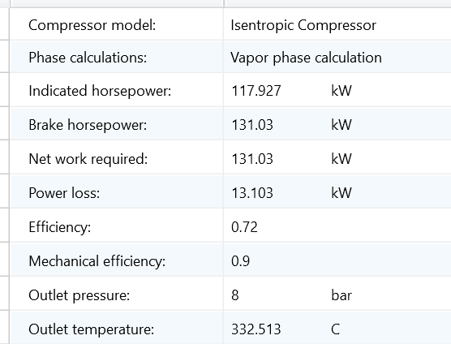

C-102

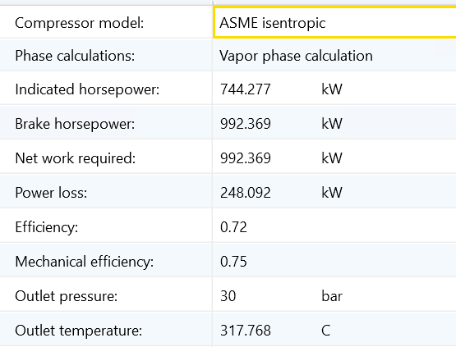

New C-102

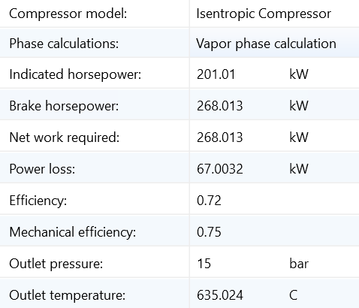

New C-103

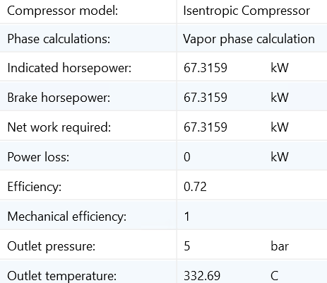

E-101

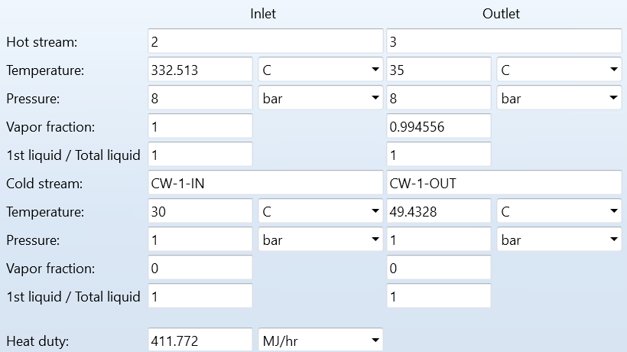

E-102

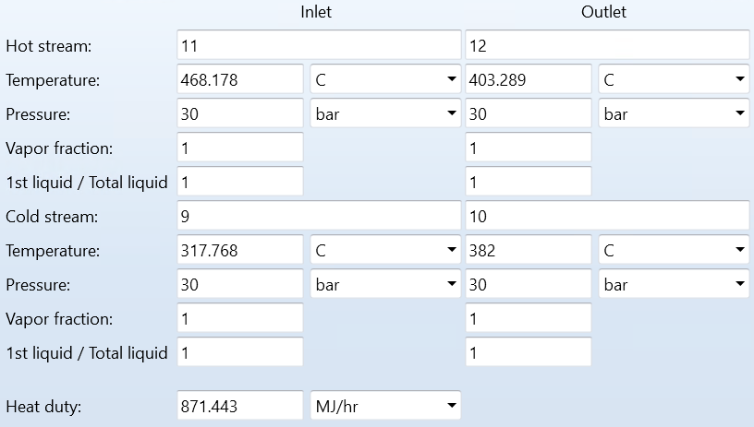

E-103

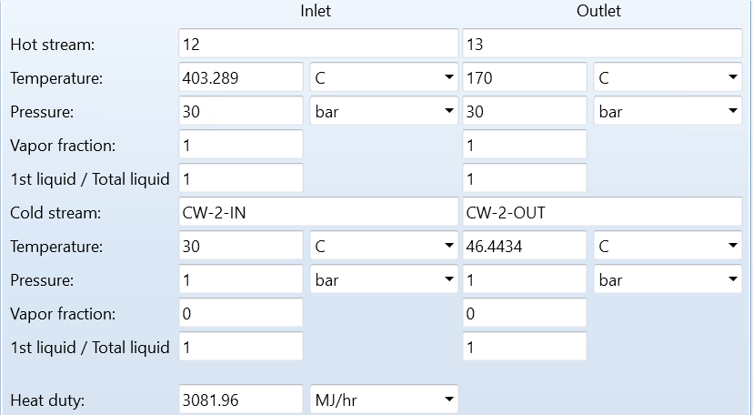

E-104

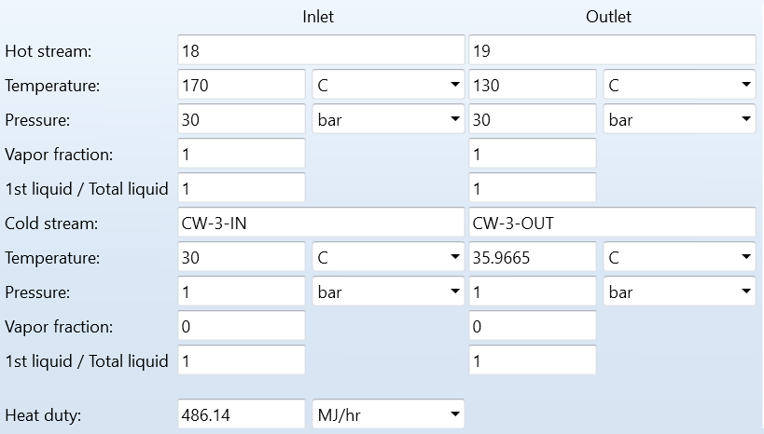

E-105

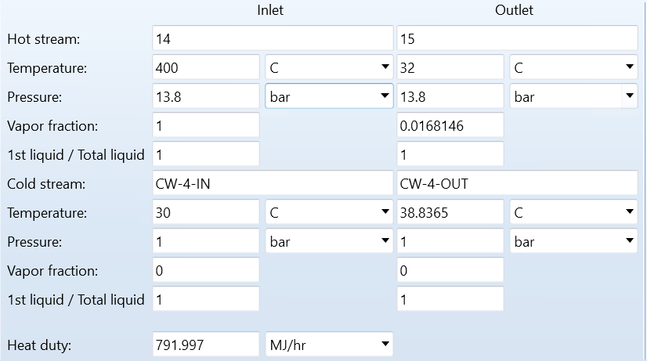

E-106

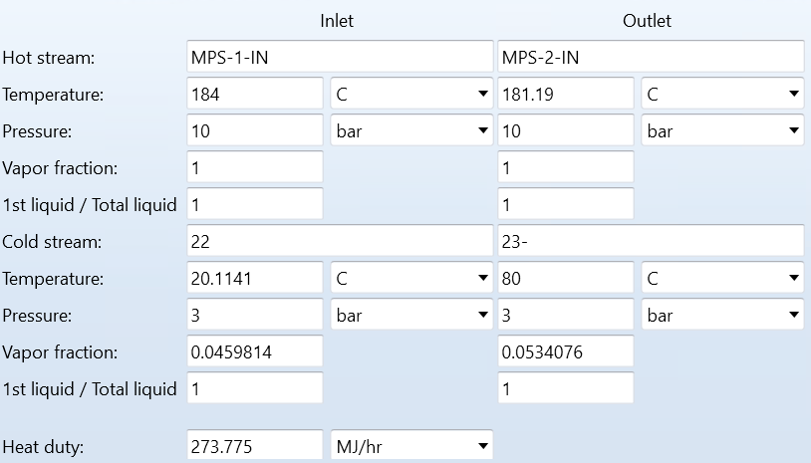

E-107

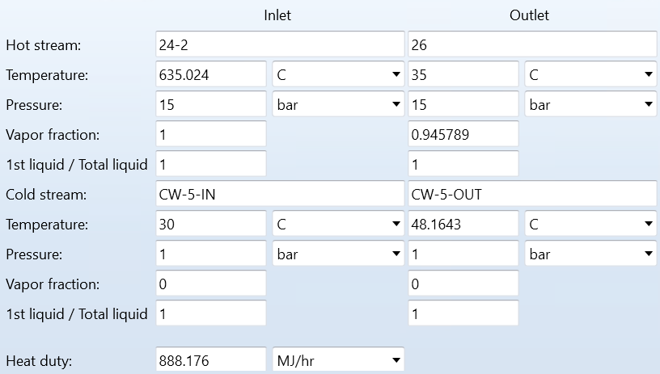

E-108

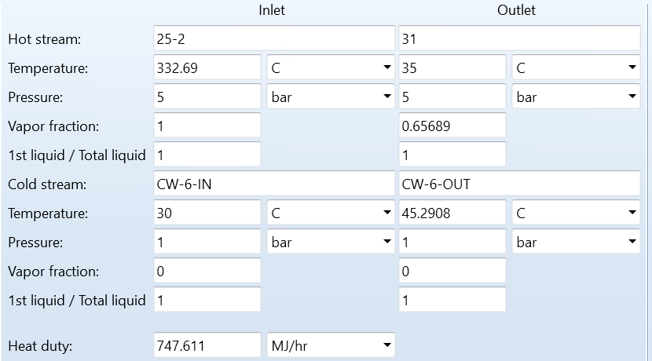

ELEC-1

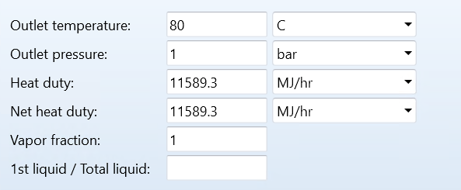

ELEC-2

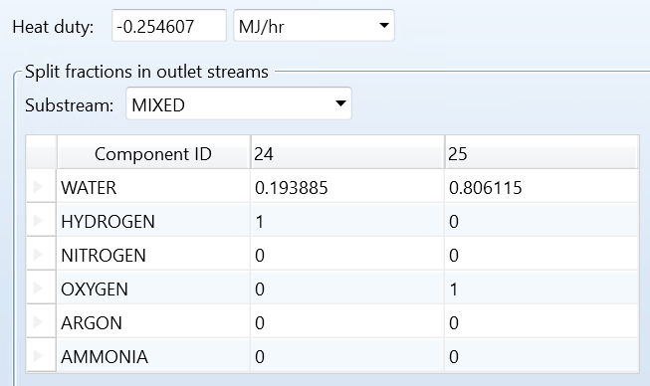

FK-SEP

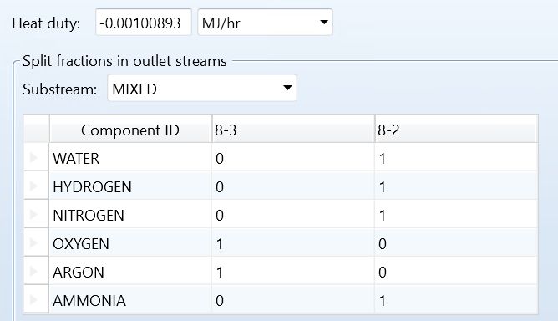

P-101

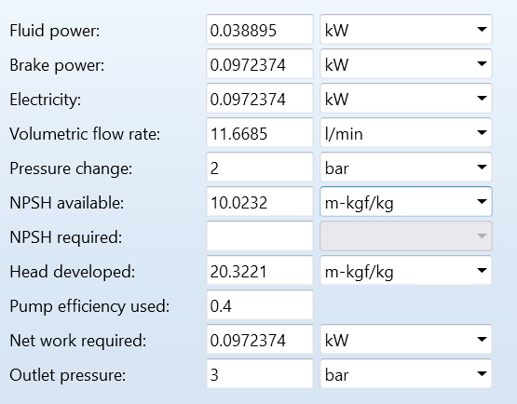

PSA

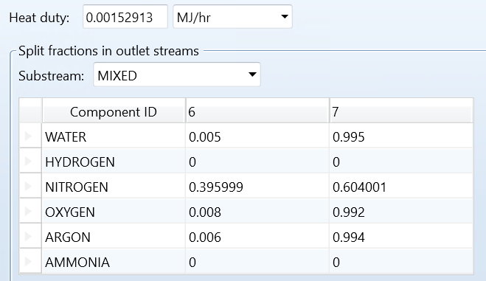

R-101

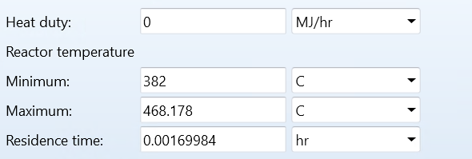

V-101

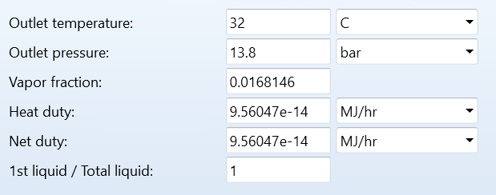

V-102

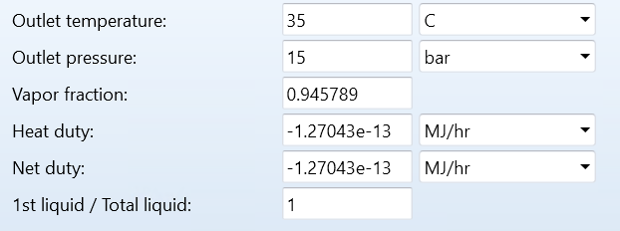

V-103

